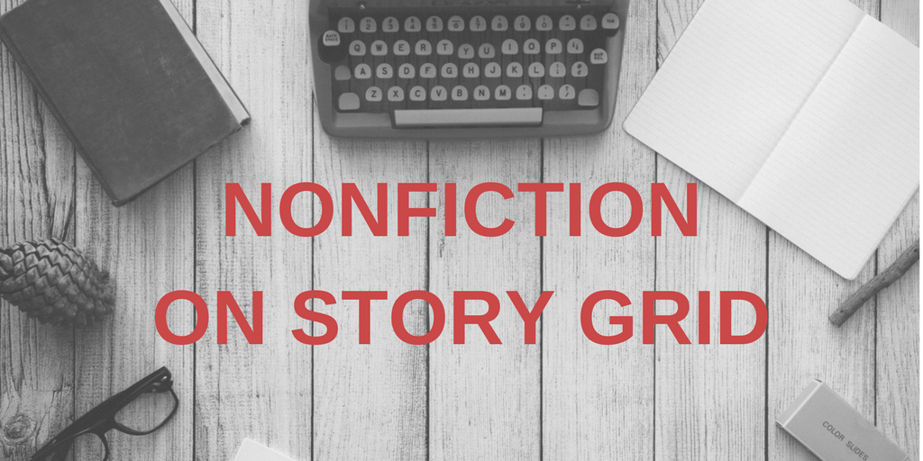 | The great thing about a big idea book is that the reader gets so captivated with the storytelling that they actually have to stop themselves and say, “Oh my gosh! That’s a great idea as a tactic. I’m going to write that down.” But the reason why they’re reading is because they want to know what happened to Tim next. What happened next?  —Shawn Coyne  The Story Grid Podcast, episode 117
Nonfiction On the Podcast

Better Nonfiction with Story Grid/Storygridding Nonfiction (episode 15)  Story Grid and Nonfiction (episode 46)  Editing Nonfiction (episode 88)  Nonfiction Conventions and Obligatory Scenes (episode 89)  The Craft of Nonfiction (episode 90; no transcript for this one)  Specificity for Nonfiction Storytelling (episode 91)  Finding My Why (episode 115)  Truth vs. Truth (episode 116)  Tell Your Story (episode 117) | 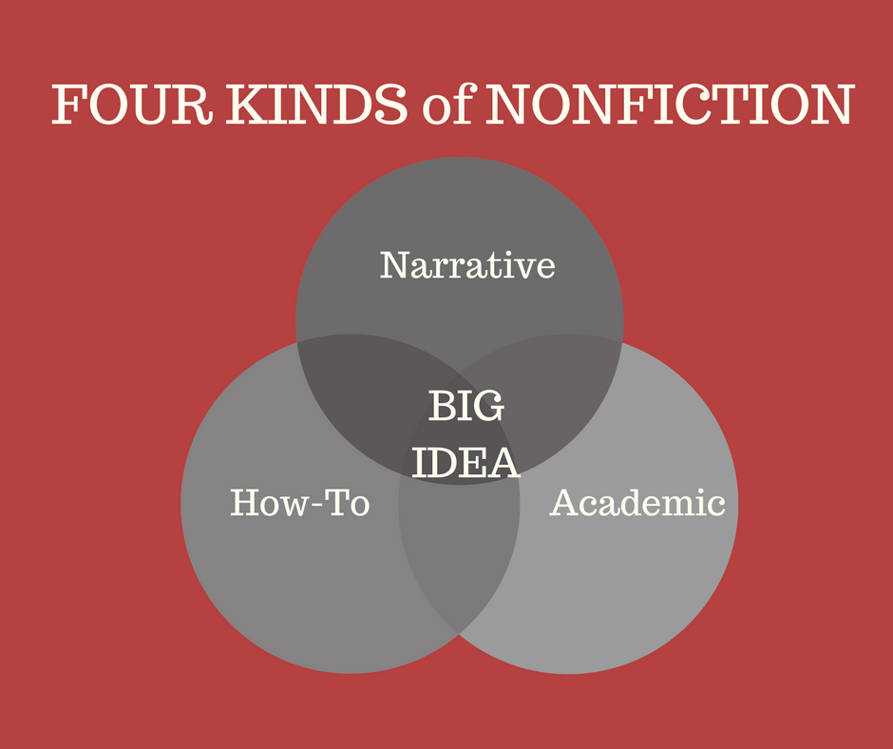

Articles on StoryGrid.com:
(Most are part of Shawn’s series on Malcolm Gladwell’s The Tipping Point)

Nonfiction’s Big Genre Silos
What to Expect from a Big Idea Book
Ethos, Logos, and Pathos
The Internal Genre of The Tipping Point
Hero, Victim, Villain
Mea Culpa
Unknown Unknowns
Nine Must-Haves
Four Nonfiction Points of View
Want and Need in Nonfiction
Big Ideas
Hitting the Wall
In the Weeds
Staring Down the First Draft
The Stakes
Ten Thousand Hours
Writing within the Context of No Context
Stealing Ideas

Making Connections
Finding a Voice
Recognizing Opportunity
Narrative Altitude
Four Thousand Words for Seven Figures
Out of the Rabbit Hole
Trinities
The Tipping Point on One Piece of Paper
The Story Grid Spreadsheet for The Tipping Point
The Middle Build of The Tipping Point
The Ending Payoff Spreadsheet of The Tipping Point
Infographic Overkill
Accentuate the Positive
A Prescient Warning
Narrative Nonfiction Storytelling
Think Big: Tackling the Big Idea Nonfiction Story
Mind Behind the Prose

